Press Announcement
EDAG CityBot at University of Applied Sciences, Fulda
Students carrying out practical research on highly automated multifunctional vehicle

Fulda, May 28, 2024 – EDAG Engineering GmbH today announces its cooperation and close collaboration with the University of Applied Sciences in Fulda. To this end, EDAG is loaning the university a model of the EDAG CityBot, which students will be using for research and development.
The EDAG CityBot is a networked, highly automated vehicle capable of performing a wide variety of tasks, depending on requirements and configuration. Its modular design enables the system to be put to multifunctional use. Application scenarios, for example, include the transport of people and goods, city cleaning services and park maintenance. As a result of the Campus FreeCity project, which was funded by the German Federal Ministry of Transport and Digital Infrastructure and ends in August 2024, the first joint research results for the concept are already available.
Close cooperation throughout numerous phases
The two partners plan to build on the current research results. Students from two departments, namely Applied Computer Science and Electrical Engineering and Information Technology, are carrying out practical work on the 2020 model of the EDAG CityBot. The first stage involves lectures to teach the initial basics of the model. This will be followed by a phase of specific projects involving the vehicle, in which several teams will be working on various projects and presenting the results in final presentations. The innovative teaching concept provides students at the University of Applied Sciences in Fulda with a unique opportunity for hands-on involvement in a future-oriented mobility system. The teams can try out a wide variety of scenarios, and benefit from a real-life project in their professional careers.
EDAG is letting the University of Applied Sciences have an EDAG CityBot on loan, and providing the technical documentation for the vehicle and its software. In addition, EDAG will provide support with the introduction of current practical tasks, and take over individual seminars, subject to agreement. For optimum transfer into practice, both partners will work together to develop the seminar contents. All with the common goal of providing young talent with early hands-on support and together achieving new research results.
"By bringing science and business closer together in this way, we are strengthening our region as an attractive location for business, training and employment. We are very pleased to be playing a pioneering role in this cooperation," explains Holger Merz, Managing Director and Chief Financial Officer of the EDAG Group. "The joint exchange of knowledge is a win-win situation for both partners."
"We are delighted to see the EDAG CityBot driving around our university campus. This gives us the opportunity to introduce cutting-edge technology into teaching and provide our students with true-to-life knowledge on future-oriented fields such as mobile robot technology and autonomous driving," says Prof. Martin Kumm from the University of Applied Sciences in Fulda. "Nowadays, it is important to have real-life examples with which to prepare students for the future, and we are sure that the EDAG CityBot will be a major highlight in the curriculum."

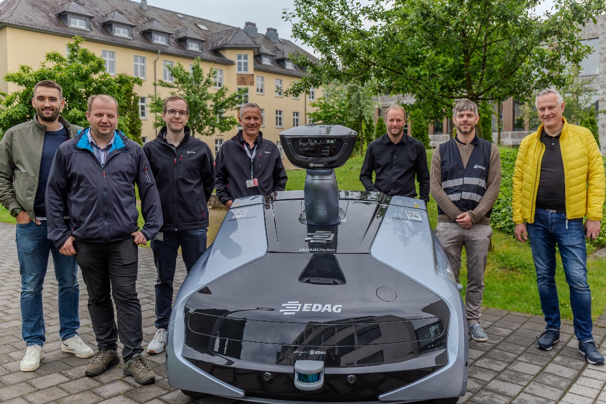
Caption: from left: Marius Schultheis (HS Fulda), Markus Hundertmark (HS Fulda), Maximilian Happel (EDAG Group), Gerhard Körbel (EDAG Group), Prof. Martin Kumm (HS Fulda), Johannes Georg (EDAG Group), Michael Jahn (EDAG Group); Photo: EDAG Group
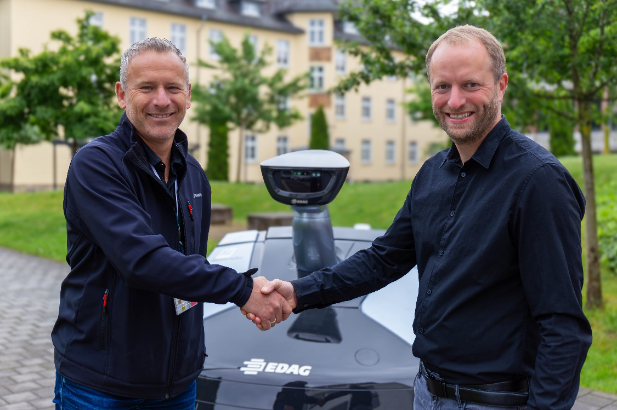
Caption: From left Gerhard Körbel (EDAG Group) hands over the EDAG CityBot to Prof. Martin Kumm (HS Fulda); Photo: EDAG Group
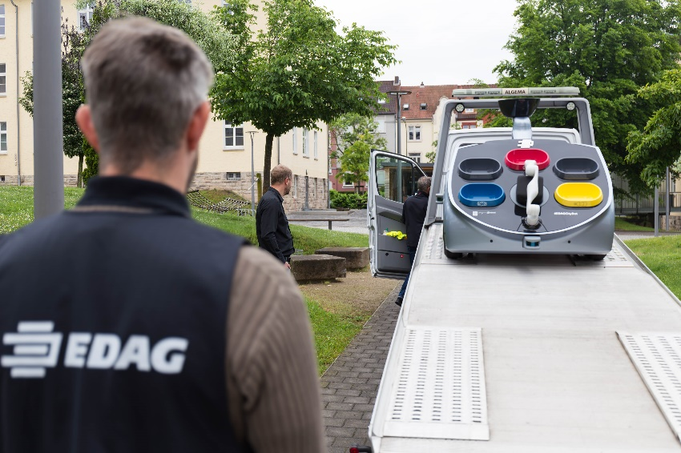
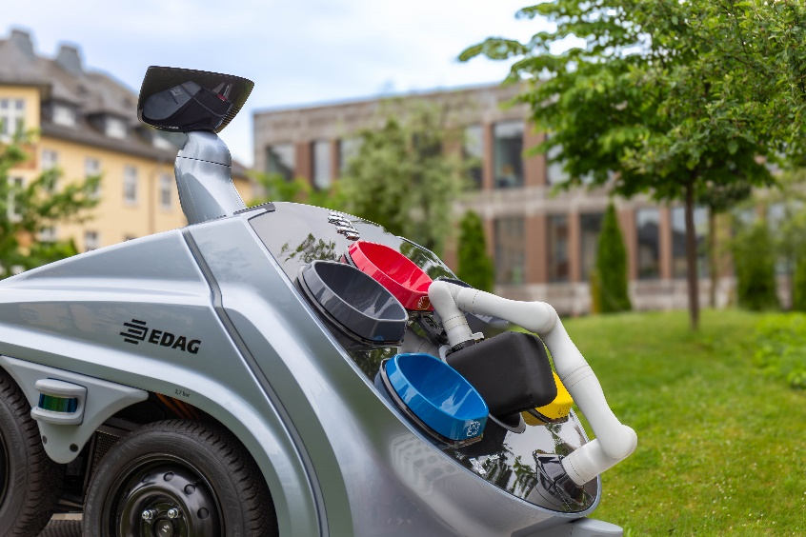
Captions: EDAG CityBot at Fulda University of Applied Sciences; Photo: EDAG Group

About the EDAG Group
The EDAG Group is a globally leading, independent engineering service provider that combines excellent engineering with the latest technology trends.
With a global network of some 70 branches, the EDAG Group realizes projects in the Vehicle Engineering, Electrics/Electronics and Production Solutions segments. Drawing on more than 50 years of engineering experience, EDAG's proprietary 360-degree development approach has become a hallmark of quality in the holistic development of vehicles and smart factories. The company's interdisciplinary expertise in the areas of software and digitalization provides it with crucial skills to actively shape dynamic transformation processes as an innovative partner.
With an interdisciplinary team of around 8,900 experts, the EDAG Group develops unique mobility and industrial solutions for customers that include the world's leading automotive and non-automotive companies. The company, which has been listed on the stock exchange since 2015, generated revenues of € 844 million in 2023. For more information, see the EDAG Group website: www.edag.com
Do you have any questions, or need further information?
I look forward to hearing from you:
Felix Schuster Head Office
Head of Marketing & Communications EDAG Engineering GmbH
Cell phone: +49 173 7345473 Kreuzberger Ring 40
Email: felix.schuster@edag.com 65205 Wiesbaden
www.edag.com

