**Press Announcement**

**EDAG CityBot at the Digital Summit 2024**  
*The EDAG Group's innovative mobility system was presented to a high-caliber audience at the Digital Summit in Frankfurt.*

**Frankfurt, 10/22/2024** – The EDAG Group exhibited its modular robot vehicle, the EDAG CityBot, at the two-day Digital Summit held by the German government on October 21 and 22, 2024. In this framework, the potential of the networked and automated robot fleet was recognized by a large audience representing the fields of politics, business and science.

**EDAG CityBot as a pacesetter in the digital transformation of Germany**

With over 1500 participants, the Digital Summit is the German government's central platform for shaping digital transformation. The focus of the event is on digital issues relevant to Germany's future and the presentation of pioneering projects such as the EDAG CityBot. Chancellor Olaf Scholz, Economics Minister Robert Habeck and Transport Minister Volker Wissing had a personal, first-hand look at the development service provider's unique mobility concept. Within the framework of a submissions process, the Federal Chancellor had selected the EDAG Group's mobility system as the Chancellor's exhibit at the Digital Summit.

The on-site presentation demonstrates the importance of the EDAG Group in the context of the digital and sustainable transformation of Germany. Chancellor Scholz on the technological innovation and the many possible applications offered by the robot vehicle: “The product is a good example of how digitalization and sustainable mobility can be made to work together."

**Innovative solution for a wide variety of tasks**

The EDAG CityBots are highly automated, networked, emission-free and driverless robot vehicles which, thanks to their modular design, can perform a variety of tasks in urban areas. Whatever use they are put to – as transport vehicles, cleaning units or mobile assistants – the CityBots' flexibility makes them a key factor in the sustainable, profitable and efficient transportation of tomorrow. Specially developed control software navigates the automated vehicles safely through traffic, avoiding congestion. Optionally, the robot vehicles can also be teleoperated. To automate the driving functions, the CityBots have a configurable set of sensors, primarily consisting of LIDARs and 3D stereo cameras. The driving functions are implemented by means of a scalable software platform with 40 core software modules. To communicate, the robot vehicles use 5G mobile communications technology and the internet with an external mobility backend developed by the EDAG Group.

The integration of infrastructure and environmental sensors ensures that the CityBots can be used on a needs-driven basis and that system automation can be expanded. A specially developed booking system enables users to order the various CityBot transport and work services by cell phone or tablet.

**A separate ecosystem for smart cities and airports**

"The presentation at the Digital Summit confirms the relevance of our technology and provides us with additional momentum for further development. We have provided an impressive demonstration of the capabilities of the EDAG CityBot and the fields of application in which it can realize its full potential,” explained Harald Keller, President and CEO of the EDAG Group. “We are now looking to enter into dialog with investors and business partners interested in using the EDAG CityBot to increase efficiency and meet the challenges of urban mobility and logistics. As we see it, the next logical step will be to use it at airport sites.”

Following a two and a half year development and production period, two EDAG CityBots with a number of module variants have been relocated to a real playing field: the Deutsche Bank Park in Frankfurt. In a research project funded by the German Federal Ministry of Transport and Digital Infrastructure, a consortium from science and industry has this year been testing the use of a modular vehicle fleet for stadium operations and stadium logistics in the immediate vicinity of Eintracht Frankfurt's training ground. Under the project title “Campus FreeCity”, the stadium grounds served as a small-scale smart city. Starting with passenger transport, the collection of green waste and the watering of parks, and culminating in the transport of workers and their work materials to their job locations: impressive proof was provided of the numerous fields of application and the potential of the vehicle fleet. After intensive research and development work, the end of October will see the conclusion of the final test and evaluation phases.

This year's Digital Summit focused on the interaction between artificial intelligence, autonomous driving and networking in the smart city. The EDAG CityBot combines all these aspects in a fully integrated ecosystem, while at the same time providing a concrete solution to the challenges posed by urban mobility and logistics – from reducing emissions to optimizing traffic flows and urban services. Being a driverless vehicle, the EDAG CityBot is also an answer to the shortage of skilled labor. Its modularity means that it can be put to profitable use for a wide variety of tasks, around the clock, any time of the day or night. A game changer in constant use.

**About the Campus FreeCity consortium**

The consortium consists of EDAG Engineering GmbH, EintrachtTech GmbH, T-Systems International GmbH, COMPREDICT GmbH, DEKRA Automobil GmbH, the University of Fulda and the Technical University of Darmstadt. House of Logistics and Mobility (HOLM) GmbH is in charge of the overall coordination. The Campus FreeCity project is being sponsored to the tune of € 10.9 million by the Federal Ministry of Transport and Digital Infrastructure (BMDV), as part of the AI innovation initiative. The following companies joined the project as associated partners: DPD, mainova, FES.

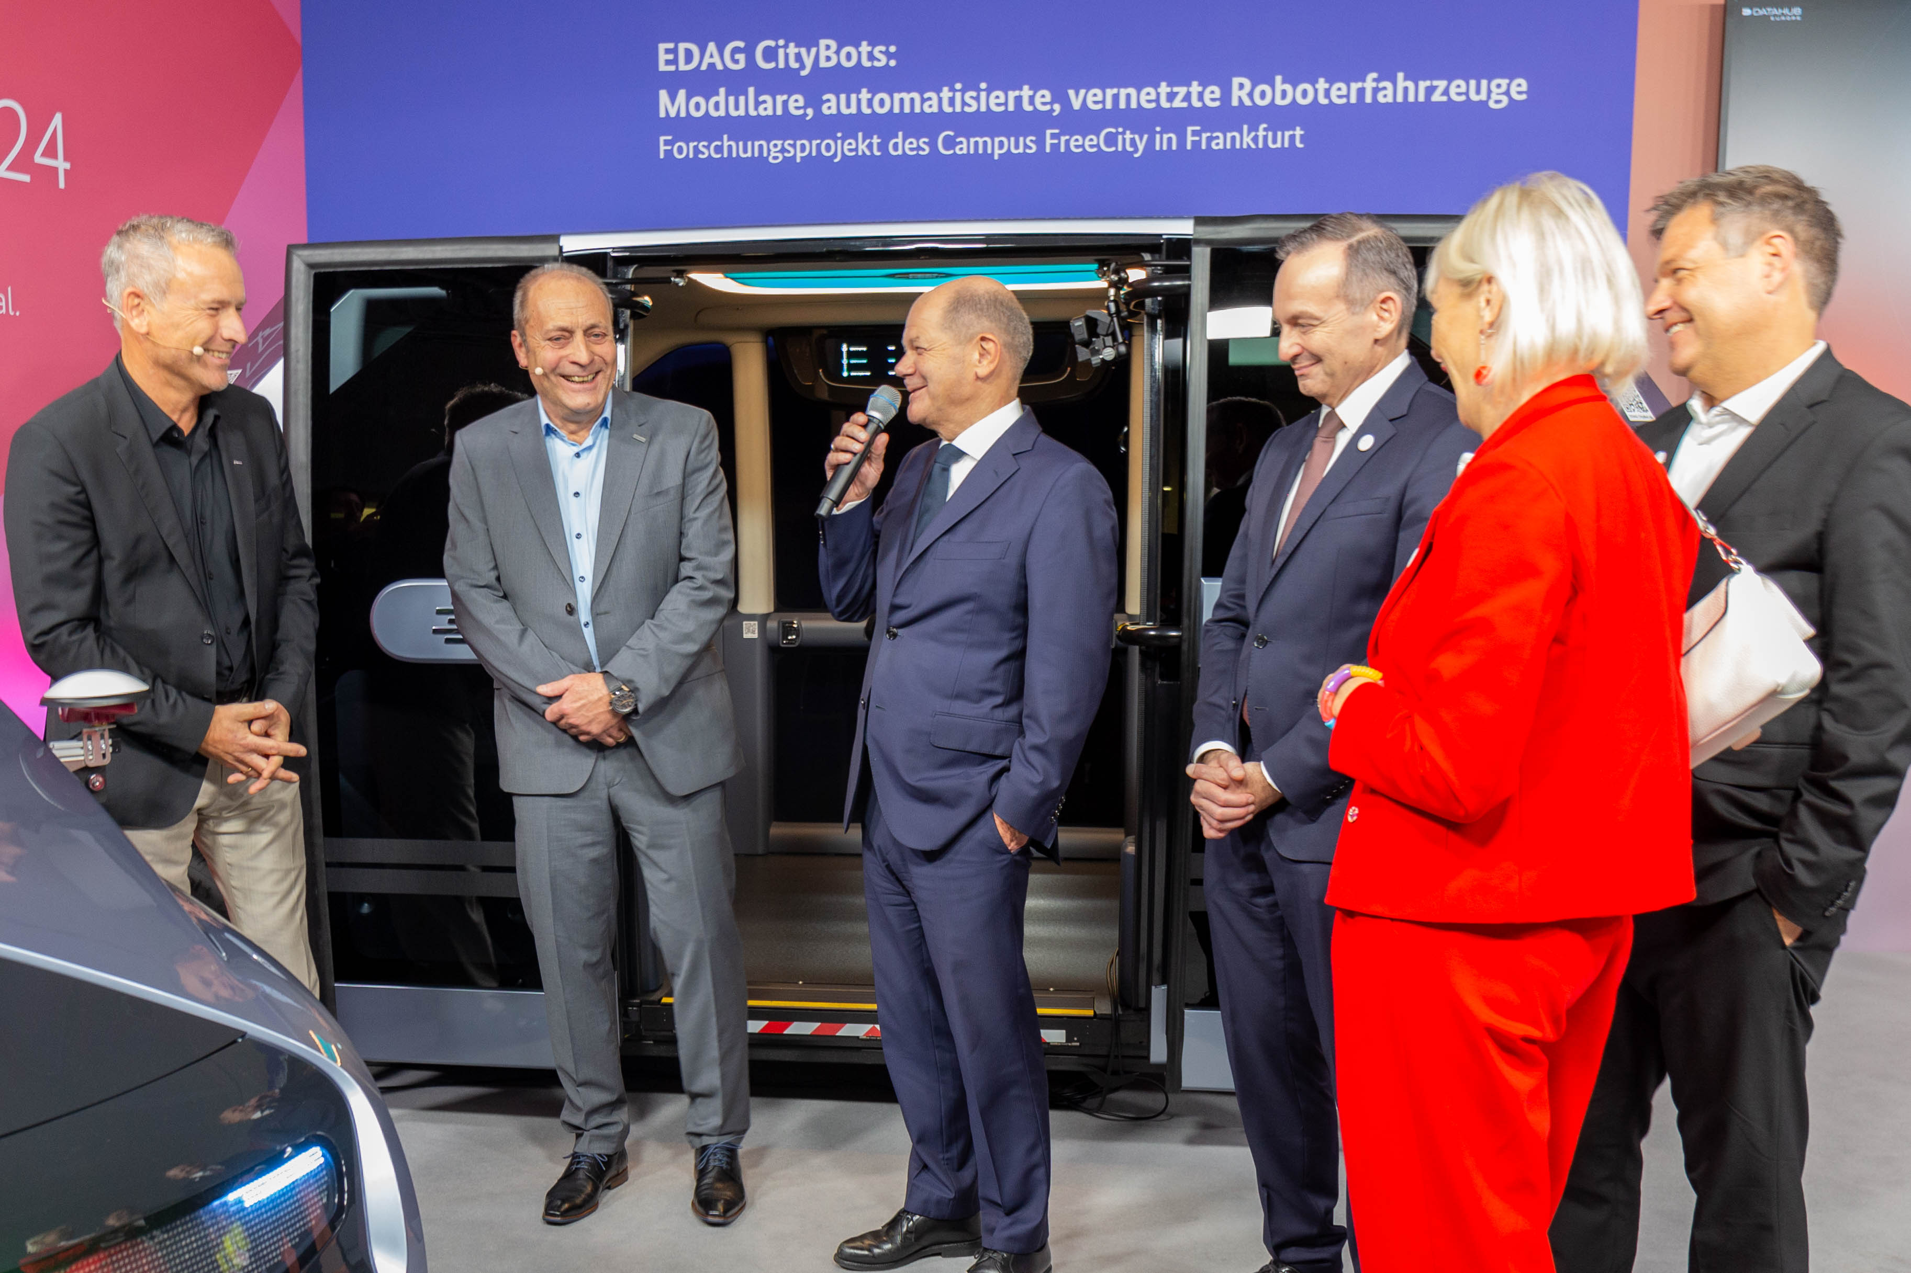

Caption: From left to right: Gerhard Körbel (Project Manager EDAG CityBot, EDAG Group), Harald Keller (CEO of the EDAG Group), Federal Chancellor Olaf Scholz, Transport Minister Volker Wissing, Hesse's Digital Minister Kristina Sinemus, Economics Minister Robert Habeck (Copyright EDAG Group)

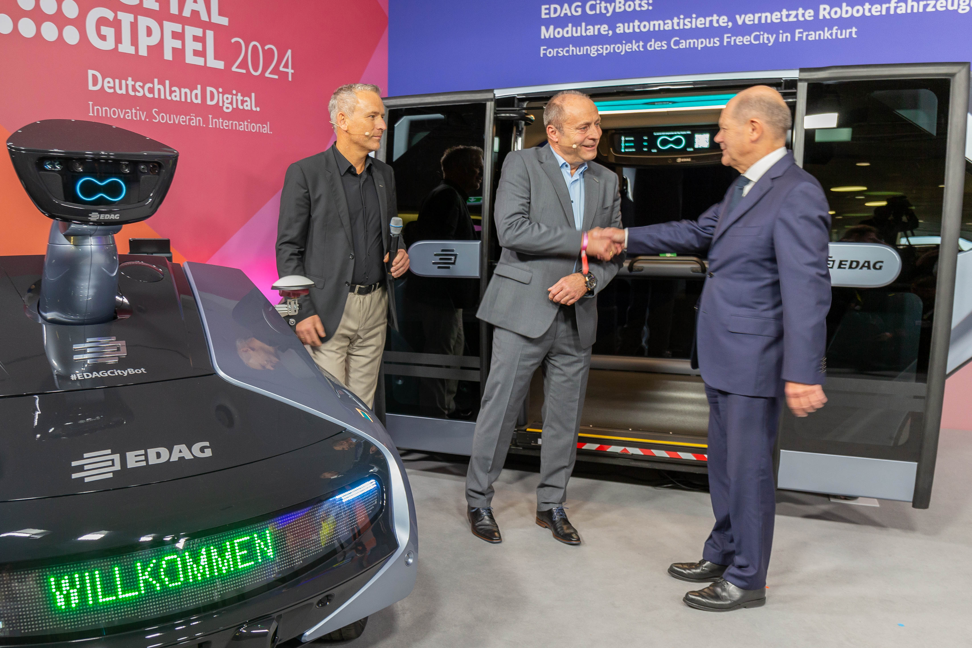

The Federal Chancellor had selected the EDAG Group's mobility system as the Chancellor's exhibit at the Digital Summit. (Copyright EDAG Group)

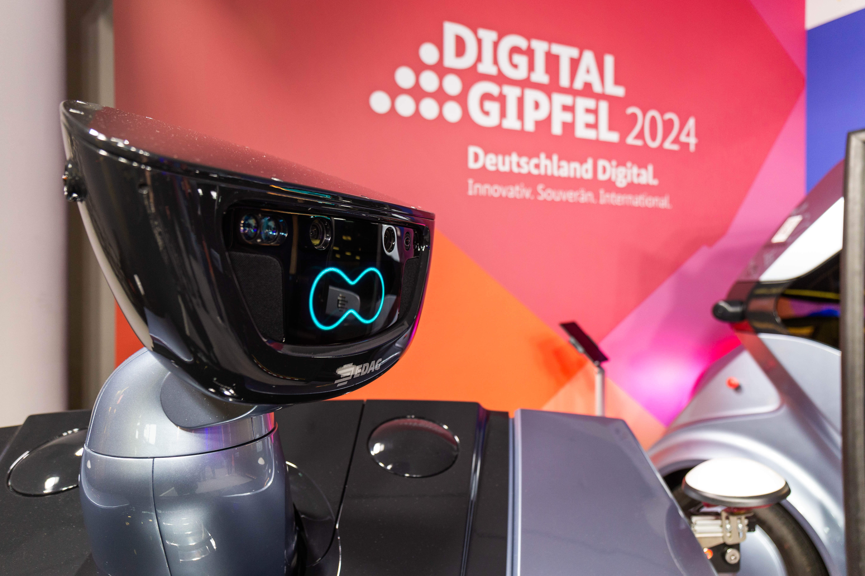

**About the EDAG Group**

The EDAG Group is a globally leading, independent engineering service provider that combines excellent engineering with the latest technology trends.

With a global network of some 70 branches, the EDAG Group implements projects in the Vehicle Engineering, Electrics/Electronics and Production Solutions segments. Drawing on more than 50 years of engineering experience, EDAG's proprietary 360-degree development approach has become a hallmark of quality in the holistic development of vehicles and smart factories. The company's interdisciplinary expertise in the areas of software and digitization provides it with crucial skills to actively shape dynamic transformation processes as an innovative partner.

With an interdisciplinary team of around 8,900 experts, the EDAG Group develops unique mobility and industrial solutions for customers that include the world's leading automotive and non-automotive companies. The company, which has been listed on the stock exchange since 2015, generated sales of € 844 million in 2023. For more information, see the EDAG Group website: [www.edag.com](http://www.edag.com)

**Do you have any questions, or need further information?  
I look forward to hearing from you:**

Felix Schuster Head Office

Head of Marketing & Communications EDAG Engineering GmbH

Cell phone: +49 173 7345473 Kreuzberger Ring 40

Email: [felix.schuster@edag.com](mailto:felix.schuster@edag.com)  65205 Wiesbaden

www.edag.com