**Press Announcement**

# **Powerful signal in times of transformation: EDAG again receives a Top Employer Award**

*Fulda, January 16, 2025* - For the 17th time, the independent international Top Employers Institute has recognized EDAG Engineering GmbH as one of the best employers in Germany. This award highlights the company as an employer which, in addition to creating excellent working conditions, also offers a future-oriented, innovative work environment – an aspect that takes on particular importance in the current period of transformation.

Compared to last year's award, this year's improved score of 80.3% is confirmation of the company's consistent development. At the same time, this award also provides us with an incentive to continue to improve, especially given the present situation. Our employees play a key role in actively shaping the transformation processes in the various areas of development”, explains Holger Merz, CFO of the EDAG Group.

Particular mention should be made here of the excellent results achieved in four categories: employer branding, working environment, onboarding and personal development. Among its various strengths, the employer brand impresses with its clear employer value proposition and authentic communication. Modern working environments offer flexibility, ergonomic workplaces, think tanks and creative meeting areas, with the addition of flexible working hours and hybrid working models. The onboarding program for new employees was again highlighted. Digital platforms, a structured Welcome Day and close interaction with managers and teams ensure a smooth and seamless start. In addition, with the recent implementation of LinkedIn Learning and EDAG Qualifying, a program for junior staff, EDAG Engineering GmbH also offers a range of targeted training opportunities.

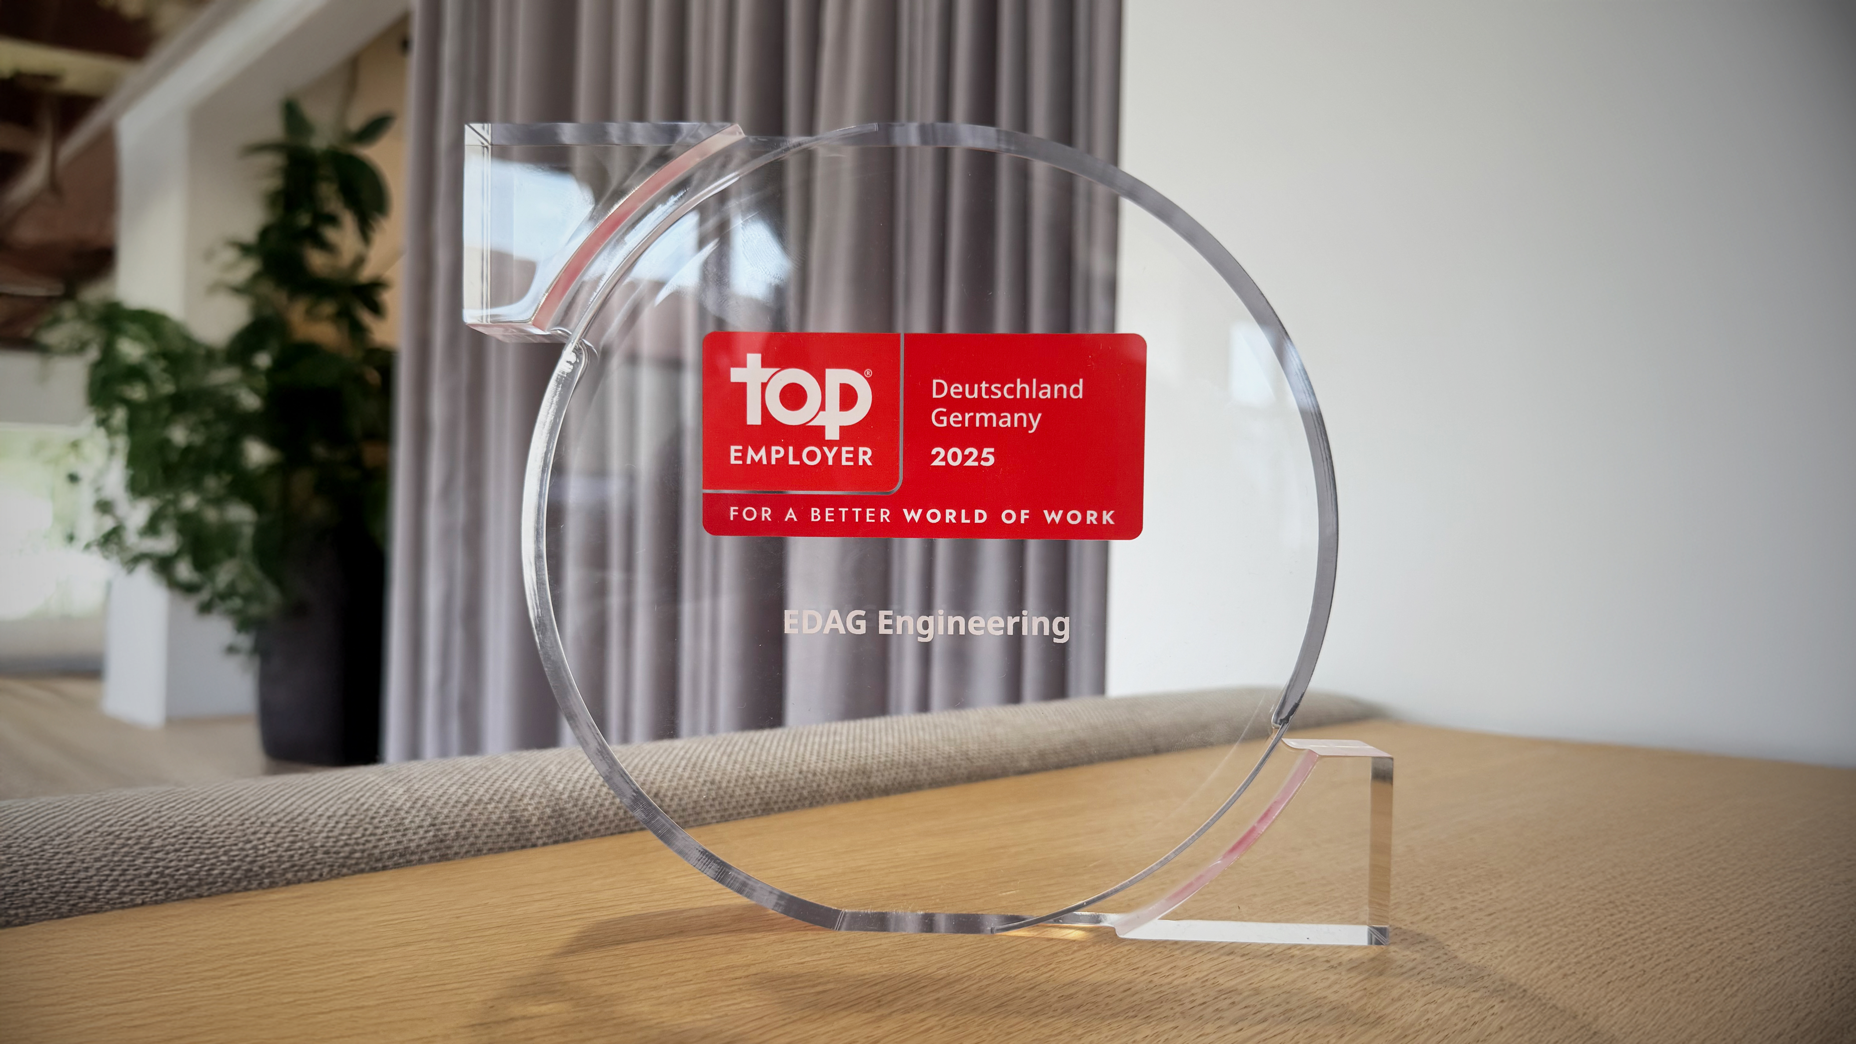Powerful signal in times of transformation: EDAG again receives a Top Employer Award (picture: EDAG Group)

**About the EDAG Group**

The EDAG Group is a globally leading, independent engineering services provider that combines excellent engineering with the latest technology trends.

With a global network of some 70 branches, the EDAG Group realizes projects in the Vehicle Engineering, Electrics/Electronics and Production Solutions segments. Drawing on more than 50 years of engineering experience, EDAG's proprietary 360-degree development approach has become a hallmark of quality in the holistic development of vehicles and smart factories. The company's interdisciplinary expertise in the areas of software and digitization provides it with crucial skills to actively shape dynamic transformation processes as an innovative partner.

With an interdisciplinary team of around 8,900 experts, the EDAG Group develops unique mobility and industrial solutions for customers that include the world's leading automotive and non-automotive companies. The company is listed on the stock exchange since 2015 and generated revenues of € 844 million in 2023.

For more information, see the EDAG Group website: www.edag.com

**Do you have any questions, or need further information?**  
**I look forward to hearing from you:**

Felix Schuster Head Office

Head of Marketing & Communications EDAG Engineering GmbH

Cell phone: +49 173 7345473 Kreuzberger Ring 40

Email: [felix.schuster@edag.com](mailto:felix.schuster@edag.com)  65205 Wiesbaden

www.edag.com