Press Announcement

EDAG Real Lab: CityBots for the Urban Mobility of the Future
EDAG Group Sets up Test Site for Highly Automated CityBot Vehicles

Fulda, 8/11/2023 - The EDAG Group, the world's largest independent engineering service provider to the mobility industry and a technology developer for industrial solutions, has carried out the first live tests on the highly automated CityBot vehicles at the real lab at its premises in Fulda.

What we have with the EDAG CityBots is a carefully thought-out ecosystem. With the help of specially developed control software, the multifunctional, highly automated robots are networked with one another and with the smart city infrastructure. The CityBots are modular in design, enabling them to be put to multifunctional use. This means that the robot vehicles can, for example, be used as passenger cells, cargo carriers, city cleaning devices or for park maintenance, around the clock, as and when needed.

"The EDAG CityBot is the answer to every mobility challenge," emphasizes Harald Keller, COO of EDAG Engineering GmbH during a presentation of the CityBots at the EDAG Group's site. "At the real lab in Fulda, we are testing all the functionalities of the EDAG CityBots and putting the entire system into operation, so that we have a stable system for the next stage, when we move to the 42-hectare site in Frankfurt. In August, we carried out the first tests on automated driving maneuvers here."

Important visitor in Fulda
While visiting Fulda during her summer trip, Hesse's Digital Minister Prof. Dr. Kristina Sinemus had a look at the future of mobility. At the EDAG Group's site, the minister was provided with information on the fully integrated approach to solving the urban mobility challenges of tomorrow. She gained insights into how the idea of employing a multifunctional, highly automated fleet of robots for extensive mobility, transport and service tasks in the smart city could become reality.

"This is a place where history is being made, where modern technologies are demonstrated and the great potential of digitalization can be experienced," said the minister during her tour of the EDAG site in Fulda. Digitalization is the key to the mobility revolution. "In Hesse, we want to be pioneers for innovative transport solutions and the conditions for this are good," said Prof. Dr. Sinemus.

Further trials in Frankfurt
While the preliminary trials and the initial commissioning EDAG CityBot use cases are being carried out in Fulda, the overall system is to be researched at the Deutsche Bank Park in Frankfurt. This is to be done in the course of the two-and-a-half-year "Campus FreeCity" funded project. Within this framework, the EDAG Group is working with a consortium from science and industry to investigate how highly automated robotic vehicles can be used to make sustainable improvements in cities.

Johannes Barckmann, EDAG CityBot Concept & Product Owner explains the differences between the two laboratories: " In contrast to our own company site, we have in Frankfurt a site over which we do not have full control. Contact with pedestrians, cyclists and delivery vehicles enables us to gather valuable insights for scaling highly automated vehicles. In addition to urban mobility, other potential applications for our EDAG CityBots are large logistics centers and airports. For technological game changers like the EDAG CityBot, real labs are the first step into the future. This is where we will see what challenges – technical, ethical or social – lie ahead."
Future-viable project
As Digital Minister Sinemus sees it, model projects such as the "Campus FreeCity" project are pointing the way to the future of urban mobility in a smart city: "Citizens and companies alike will benefit if small test fields are further developed to include entire cities. And this is our aim: digitalization should benefit everybody." Since 2021, the digital minister's portfolio has included funding for smart municipalities and regions in the "Starke Heimat Hessen" program. In the meantime, the program is sponsoring 73 projects involving 130 participating municipalities and a funding volume of more than € 50 million. The EDAG Group is also involved in one of these projects: A heavy rain early warning system has been installed in the district of Fulda, to provide a local means of alerting and defending the population against heavy rain and flash flood hazards in good time.
Johannes Barckmann gives an outlook of the next project steps: "In October, we will be moving to the grounds of the Deutsche Bank Park with our EDAG CityBot vehicles. In this real lab, we and the other Campus FreeCity project partners can test and further develop the EDAG CityBots in an overall system that works around the clock. For a completely new chapter in urban mobility. We are looking forward to providing customers and journalists with exclusive insights into the laboratory in Frankfurt and other innovative fields handled by the EDAG Group at an event to be held in Frankfurt from November 21-23."
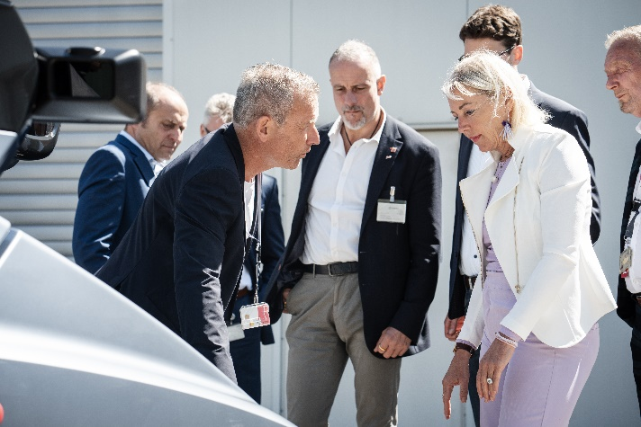
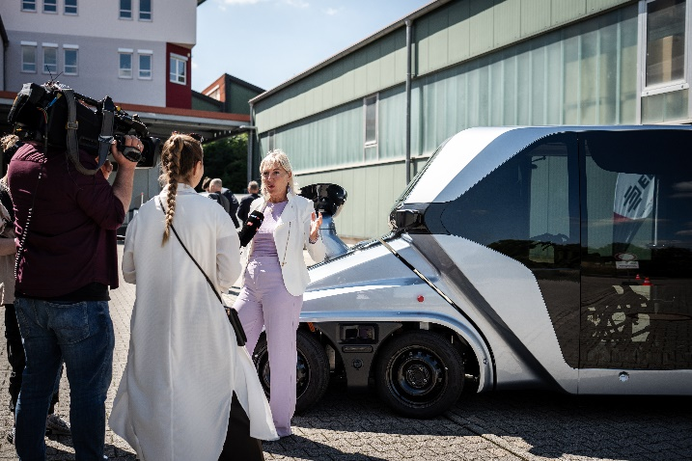
Caption: Hesse's Digital Minister Prof. Dr. Kristina Sinemus visits engineering service provider EDAG. Photo: EDAG Group
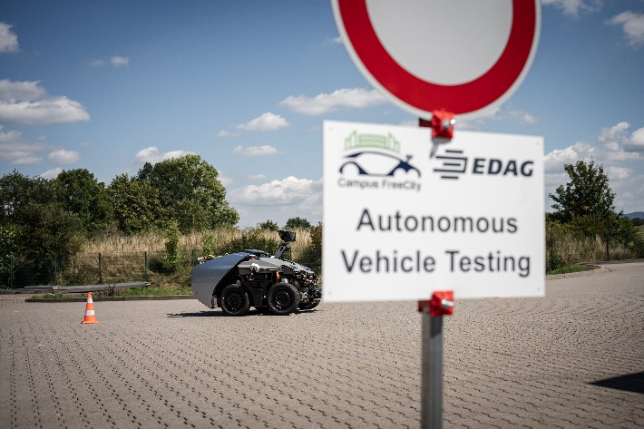

Caption: First live tests carried out on highly automated robot vehicles – EDAG CityBots – at the EDAG Group's premises in Fulda. Photo: EDAG Group
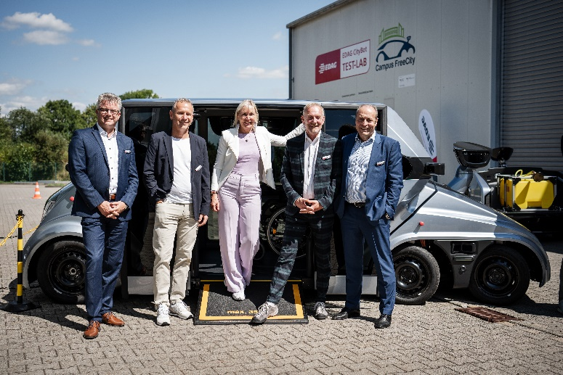

Caption: From left to right: Dirk Keller (Managing Director of EDAG Production Solutions), Gerhard Körbel (EDAG's Overall Campus FreeCity Project Manager), Prof. Dr. Kristina Sinemus, Johannes Barckmann (EDAG CityBot Concept & Product Owner), Harald Keller (COO EDAG Engineering GmbH) Photo: EDAG Group

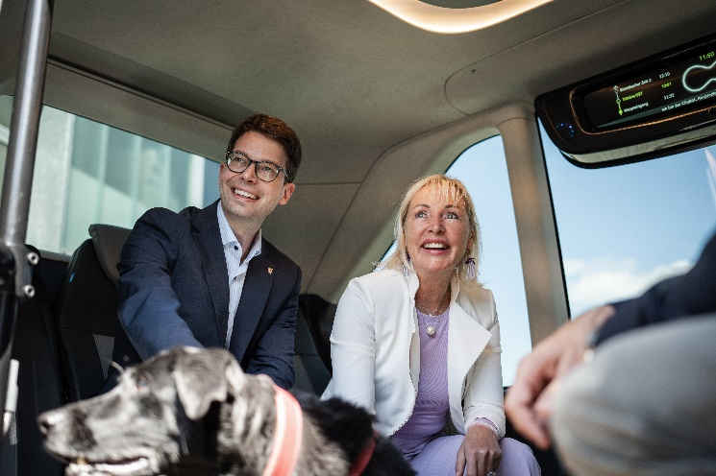
Caption: Hesse's Digital Minister Prof. Dr. Kristina Sinemus with Sebastian Müller (Member of Parliament) and dog Lizzy in the EDAG CityBot. Photo: EDAG Group

About EDAG
EDAG is the world's largest independent engineering service provider to the global mobility industry.
We regard mobility as a fully integrated ecosystem, and offer our customers technological solutions for more sustainable, emission-free and intelligently networked mobility.
With a global network of some 60 branches, EDAG provides engineering services in the Vehicle Engineering, Electrics/Electronics and Production Solutions segments.
With our interdisciplinary expertise in the fields of software and digitalization, we possess the key skills to help actively shape the dynamic transformation process the mobility industry is currently undergoing. Digital features, autonomous driving, artificial intelligence, alternative powertrains, new mobility concepts and the vision of a networked smart city have become an integral part of our portfolio. Embedded in EDAG's own 360 degree approach to the development of complete vehicles and production facilities, we are a competent partner for sustainable mobility projects. It is in the DNA of the company to actively shape the future of mobility and transfer new technologies and concepts into series production. Today, EDAG is one of the TOP 20 IT service providers in the German mobility sector.
Our customers include leading international OEMs, tier 1 suppliers and startup companies from the automotive and non-automotive industries, all of whom we serve globally with our workforce of approximately 8,400 experts in 360-degree engineering.
In 2022, the company generated sales of € 796 million. On December 31, 2022, EDAG employed a global workforce of 8,412 (including apprentices).

Do you have any questions, or need further information?
I look forward to hearing from you:
Felix Schuster Head Office
Head of Marketing & Communications EDAG Engineering GmbH
Cell phone: +49 173 7345473 Kreuzberger Ring 40
Email: felix.schuster@edag.com 65205 Wiesbaden
www.edag.com

